Тема урока: | CHRISTMAS IN THE AIR

Учебные цели: | Активизация новой лексики по теме «Рождество».  Обучение ведению диалога-обмена мнениями по изучаемой теме.  Обучение самоконтролю с опорой на аудиозапись.  4) Актуализация навыков чтения и произношения.
Развивающие цели: | 1) Развитие умения логически мыслить.  2) Развитие аналитических способностей.
Воспитательные цели: | 1) Привитие интереса и уважения к традициям другого народа.  2) Воспитание толерантного отношения к традициям и обычаям людей англо-говорящих стран.
Оборудование: | Магнитофон с записью, мультимедийный проектор, раздаточный материал.

1.  2)  3). | Ход урока.  .Организационный момент.  -How are you, Tanya?  -Fine, thanks. And you, Sasha?  -I see that you are fine/  Today is the 23rd of December. And you know that in Great Britain people celebrate Christmas on the 25th of December. It’s one of the greatest holidays not only in G.B., but all over the world. On Christmas day the whole family is together. They give presents each other. There is a Christmas tree in every house.  Фонзарядка  First we’ll do our warm-up- activities.  Ring, ring the bells  Ring them loud and clear  To tell the children everywhere  That Christmas time is here.  a) Listen to me.  b)Find the words with the sounds [r] [t]  c) Read to yourself.  d) Read aloud.  Повторение лексики.  At the previous lesson we’ve learned a lot of words. Listen and repeat. (Дети повторяют лексику после учителя и эти слова вывешиваются на доске.)  Santa Claus  Carol  To decorate  Christmas  Pudding  Christmas Eve  Card  Turkey  To begin  stocking
4)  5)  6) | Просмотр презентации.  I’ve made a presentation about Christmas. Do you want to know any extra facts?  Выполнение упражнений. Контроль по теме «Рождество».  - Choose and read aloud the sentences, which are true.  1. Christmas is on 25 December.  Christmas is on 1 January.  2. It’s a happy holiday only for people from Great Britain, It's a happy holiday for many people in different countries.  - Before Christmas English people are not busy.  Before Christmas English people are busy.  - On Christmas Eve people put their presents on the table.  On Christmas Eve people put their presents under the tree.  - People open their presents on Christmas Eve.  People open their presents on Christmas morning.  - For Christmas dinner people eat pizza and sugar.  For Christmas dinner people eat turkey and Christmas pudding.  - People sing carols on this day.  People don't sing carols on this day.  - Answer the questions.  - English people celebrate Christmas on 25 December, don't they?  - What do English people do before Christmas?  - Whom do they send their cards?  - Where do people put their presents on Christmas Eve?  - Who puts their stockings near their beds?  - What do English people eat for Christmas dinner?  - Where does Santa Claus put the presents for children?  - Do the children write letters to Santa Claus or to the president? 9. They have a lot of fun during Christmas, don't they?  10. What do English people sing at Christmas?  Работа с рабочей тетрадью. (W.B. p.49,ex.3W)  And what about our heroes?  We’ve forgotten about them.  - We know that Rosy…  - Agent Cute doesn’t like Christmas. Listen to the tape, your task is to read Agent’s Cute ideas about Christmas and match the ideas and lines from his Christmas song.  - Работа с рабочей тетрадью.  7) Составление диалогов.  As a rule children like Christmas. Let’s make up dialogues. I’ll give you some phrases, which help to  express your opinion.  -Your time is up.  8) Заполнение открыток.  - Well, children. We must sign the cards for Christmas. Look at the greetings at your tables, choose the best one. (Дети выбирают поздравления и подписывают открытки.)  When you wake up Christmas morning  Hope you find beneath the tree  So many lovely presents  You’ll be happy as can be!  With Best wishes for Christmas  And the New Year!  Wishing you love  And Peace at Christmas!  b) Are you ready with the cards?  c) Stand up, read aloud!  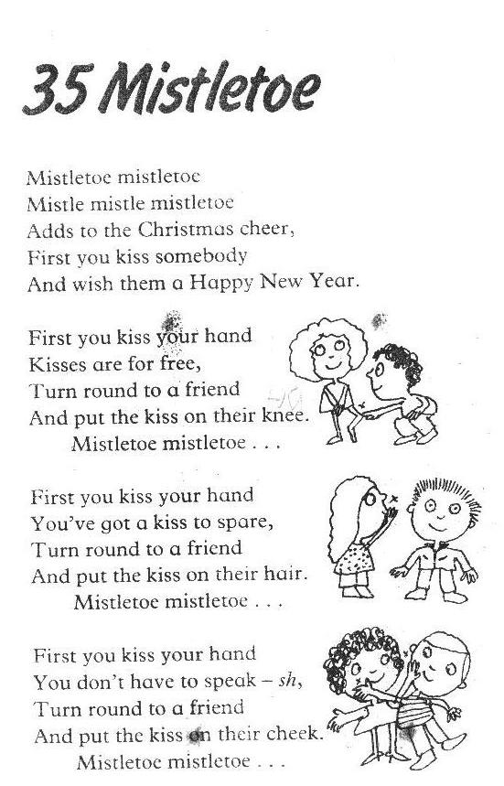  9) Песенка “Mistletoe”  10) Подведение итогов. Учитель благодарит детей за работу, а дети в это время просматривают видеоролик о Рождестве.
  + | -
  Children write letters to Santa Claus.  People buy presents and Christmas trees.  People eat different tasty food. It's always fun. | Santa Claus is a legend.  Christmas presents are expensive and useless.  People eat a lot of food. It's bad for their health  The tradition of having Christmas tree is awful.

Рецензия к уроку «Christmas in the Air»

Урок №5 (unit №7, К.Кауфман «English-6») проводится по теме «Рождество». Основной целью является активизация лексики по теме. Учитель предполагает активную работу учащихся, так как для них приготовлено большое количество различных видов деятельности. Использование презентации предусматривает развитие интереса и уважения к традициям другого народа. В конце урока учитель предлагает просмотр видеоролика для создания праздничного настроения у детей.

